Knowledge Translation Program
Li Ka Shing Knowledge Institute
St. Michael’s Hospital

Contact:
Melissa Courvoisier

E: courvoisierm@smh.ca
T: 416-864-6060 ext. 77499
Practicing Knowledge Translation: Implementing evidence. Achieving outcomes
HSR Satellite Session Resource Package

Contributors/acknowledgements
Developed by:
Julia E. Moore
Sobia Khan
Sharon Straus

Knowledge Translation Program
Li Ka Shing Knowledge Institute
St. Michael’s Hospital

Copyright claims/Disclaimers
© Copyrighted by St. Michael’s Hospital 2016.
The materials are intended for non-commercial use only. No part of the materials may be used for commercial purposes without the written permission of the copyright owner.

For questions about this report, please contact:
Melissa Courvoisier, MEd
Research Coordinator, TIES (Team for Implementation, Evaluation, and Sustainability)
Knowledge Translation Program
Li Ka Shing Knowledge Institute
St. Michael’s Hospital
Toronto, Canada
Email: courvoisierm@smh.ca
Phone: 416-864-6060 ext. 77499

Table of Contents
Knowledge to Action Model 3
Operationalizing the KTA: Developing an ETP 4
Example Project Outline: Mobilization of Vulnerable Elders (MOVE) 5
Theoretical Domains Framework (TDF) Definitions 6
TDF to COM-B Guide 10
APRAISE Criteria Definitions 11

Knowledge to Action Model
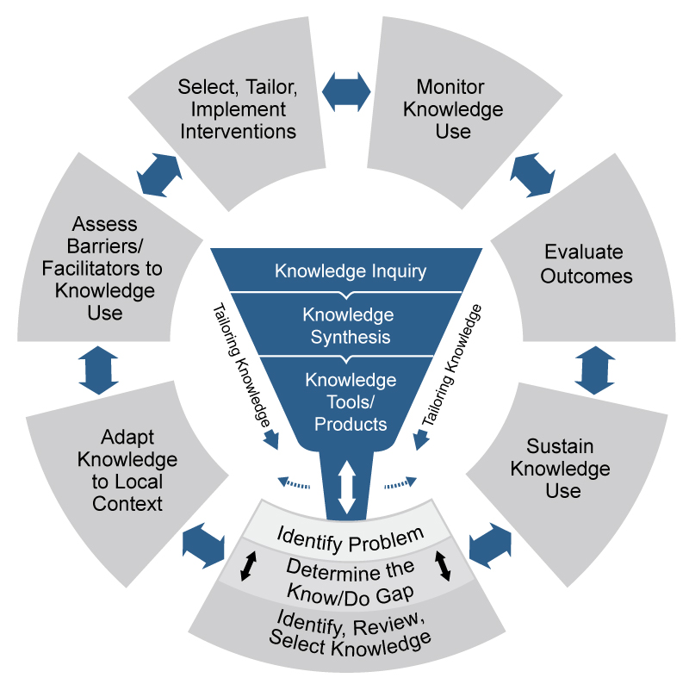

Source: Graham, I.D., et al. (2006). Lost in knowledge translation: time for a map?. Journal of Continuing Education in the Health Professions, 26(1): 13-24.

Operationalizing the KTA: Developing an ETP
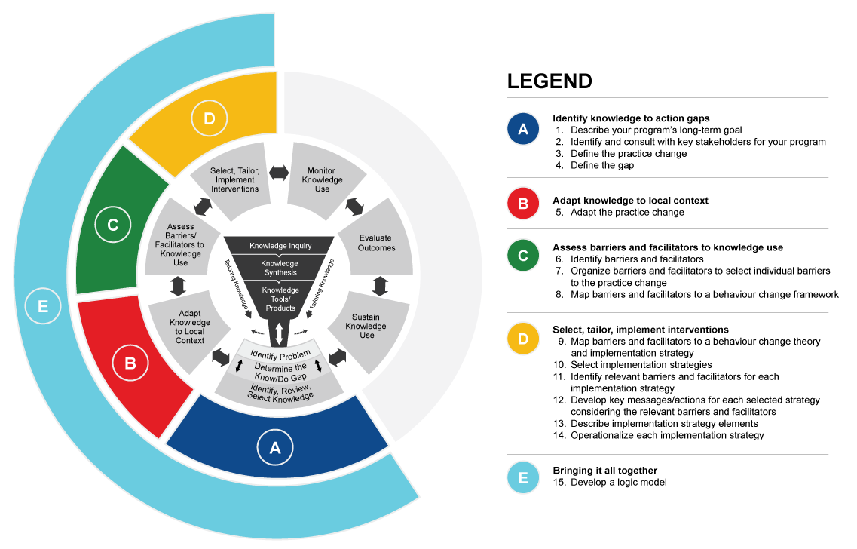

Example Project Outline: Mobilization of Vulnerable Elders (MOVE)
Questions | Project description
- What is the intended purpose/overall objective of the practice change (i.e., what impact do you hope to see as a result of the practice change)? | Increase resident mobilization, decrease amount of time spent in bed
- In which setting(s) is this practice change meant to take place? | Hospitals
- List all the key stakeholders who are expected to change as a result of the implementation. | Nurses  Physiotherapists/ occupational therapists  Physicians  Patients  Family members  Volunteers
- What specific behaviours/ practices do each of the stakeholder groups need to make? | - Assess and document mobility  - Mobilize patients at least 3 times/day  - Tailor mobility to patient’s abilities
- How often will these stakeholders engage in the practice change? | Multiple times a day, so that everyone is moving at least 3 times a day
- What is the evidence for this practice change? | Mobilizing patients can improve functional status, decrease length of stay and increase chances of returning home (in hospital settings)
- Who will be involved with implementing this change (i.e., making the change happen)? | Will create an implementation team on the unit, including nurses, OT/PT, physicians, management
For more information about MOVE, please see the MOVE website: http://movescanada.ca/
All resources can be freely accessed on the portal in the website, simply request a login.

Theoretical Domains Framework (TDF) Definitions
DOMAIN DEFINITION | CONSTRUCTS | EXAMPLE QUESTIONS
Knowledge  An awareness of the existence of something | - Knowledge (including knowledge of condition/scientific rationale)  - Procedural knowledge  - Knowledge of task environment | Do you know about x?
Skills  An ability or proficiency acquired through practice | - Skills  - Skills development  - Competence  - Ability  - Interpersonal skills  - Practice  - Skill assessment | Do you know how to do x?
Memory, Attention and Decision Processes  The ability to retain information, focus selectively on aspects of the environment and choose between two or more alternatives) | - Memory  - Attention  - Attention control  - Decision making  - Cognitive overload / tiredness | Is x something you usually do?
Behavioural Regulation  Anything aimed at managing or changing objectively observed or measured actions | - Self-monitoring  - Breaking habit  - Action planning | Do you have systems that you could use for monitoring whether or not you have carried x?
Social Influences  Those interpersonal processes that can cause individuals to change their thoughts, feelings, or behaviours | - Social pressure  - Social norms  - Group conformity  - Social comparisons  - Group norms  - Social support  - Power  - Intergroup conflict  - Alienation  - Group identity  - Modelling | To what extent do social influences facilitate or hinder x?
Social/Professional Role and Identity  A coherent set of behaviours and displayed personal qualities of an individual in a social or work setting | - Professional identity  - Professional role  - Social identity  - Identity  - Professional boundaries  - Professional confidence  - Group identity  - Leadership  - Organisational commitment | Is doing x compatible or in conflict with professional standards/identify?
Beliefs about Capabilities  Acceptance of the truth, reality, or validity about an ability, talent, or facility that a person can put to constructive use | - Self-confidence  - Perceived competence  - Self-efficacy  - Perceived behavioural control  - Beliefs  - Self-esteem  - Empowerment  - Professional confidence | How difficult or easy is it for you to do x?
Optimism  The confidence that things will happen for the best or that desired goals will be attained | - Optimism  - Pessimism  - Unrealistic optimism  - Identity | How confident are you that the problem of implementing x will be solved?
Intentions  A conscious decision to perform a behaviour or a resolve to act in a certain way) | - Stability of intentions  - Stages of change model  - Transtheoretical model  - Stages of change | Have they made a decision to do x?
Goals  Mental representations of outcomes or end states that an  individual wants to achieve | - Goals (distal/proximal)  - Goal priority  - Goal / target setting  - Goals (autonomous /  controlled)  - Action planning  - Implementation intention | How much do they want to do x?
Beliefs about Consequences  Acceptance of the truth, reality, or validity about outcomes of a behaviour in a given situation | - Beliefs  - Outcome expectancies  - Characteristics of outcome expectancies  - Anticipated regret  - Consequents | What do you think will happen if you do x?
Reinforcement  Increasing the probability of a response by arranging a  dependent relationship, or contingency, between the response  and a given stimulus) | - Rewards (proximal / distal,  valued / not valued, probable /  improbable)  - Incentives  - Punishment  - Consequents  - Reinforcement  - Contingencies  - Sanctions | Are there incentives to do x?
Emotion  A complex reaction pattern, involving experiential,  behavioural, and physiological elements, by which the  individual attempts to deal with a personally significant matter or event | - Fear  - Anxiety  - Affect  - Stress  - Depression  - Positive / negative affect  - Burn-out | Does doing x evoke an emotional response?
Environmental Context and Resources  Any circumstance of a person's situation or environment that  discourages or encourages the development of skills and  abilities, independence, social competence, and adaptive  behaviour | - Environmental stressors  - Resources / material  resources  - Organisational culture  /climate  - Salient events / critical  incidents  - Person x environment  interaction  - Barriers and facilitators | To what extent do physical or resource factors facilitate or hinder x?

Source: Michie et al. (2014). The Behaviour Change Wheel: A Guide to Designing Interventions. Great Britain: Silverback Publishing

TDF to COM-B Guide
COM-B | TDF
Capability (Psychological) | Knowledge
 | Skills
 | Memory/Decision processes
 | Behavioural regulation
Capability (Physical) | Skills
Opportunity (Physical) | Environmental context/resources
Opportunity (Social) | Social influences
Motivation (Reflective) | Beliefs about capabilities
 | Beliefs about consequences
 | Social/Professional role/identity
 | Optimism
 | Intentions
 | Goals
Motivation (Automatic) | Emotion
 | Reinforcement

APRAISE Criteria Definitions
Criteria | Definition
Appropriateness | The perceived fit, relevance, or compatibility of the intervention for a given practice setting, provider, or consumer; and/or perceived fit of the innovation to address a particular issue or problem.
Practicability/Feasibility | The extent to which the intervention can be delivered as designed through the means intended to the target population.
Risks | Consideration of the unintended consequences or side effects of the intervention.
Affordability | The extent to which the intervention can be delivered within an acceptable budget.
Impartiality | The extent to which interventions are of benefit to individuals in a non-biased and equitable manner, so as not to increase disparities in well-being and health among different sectors of society.
Sustainability | The extent to which interventions may continue to be delivered, maintained and have sustained outcomes.
Effectiveness/cost-effectiveness | Consideration of the interventions effect size in relation to the desired objectives in a real world context. Cost effectiveness refers to consideration of the ratio of effect to cost.

Sources: Michie S, Atkins L, West R: The behaviour change wheel: a guide to designing interventions. Great Britain: Silverback Pub; 2014; Wiltsey Stirman S, Kimberly J, Cook N, Calloway A, Castro F, Charns M. The sustainability of new programs and innovations: a review of the empirical literature and recommendations for future research. Implementation Science : IS. 2012;7:17. doi:10.1186/1748-5908-7-17.

